RoX Evaluation (2): SecondNet

Shuihai Hu, Wei Bai

1. Experiment Setup
   1. Topology

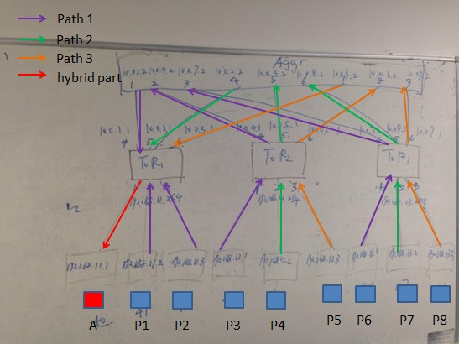

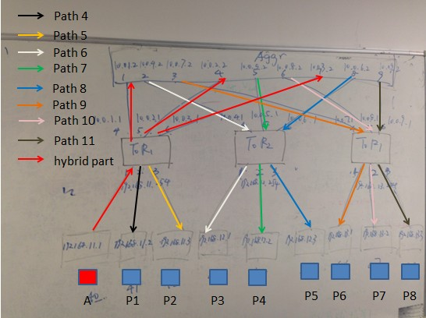

Paths

|  |  |  |  |  |
| --- | --- | --- | --- | --- |
| Path ID | Src | Dst | Path | IP |
| 1 | M2,M3,M4,M7 | M1 | M2,T1,M1  M3,T1,M1  M4,T2,A1,T1,M1  M7,T3,A1,T1,M1 | 192.168.11.51 |
| 2 | M5,M8 | M1 | M5,T2,A2,T1,M1  M8,T3,A2,T1,M1 | 192.168.11.101 |
| 3 | M6,M9 | M1 | M6,T2,A3,T1,M1  M9,T3,A3,T1,M1 | 192.168.11.151 |
| 4 | M1 | M2 | M1,T1,M2 | 192.168.11.52 |
| 5 | M1 | M3 | M1,T1,M3 | 192.168.11.53 |
| 6 | M1 | M4 | M1,T1,A1,T2,M4 | 192.168.12.51 |
| 7 | M1 | M5 | M1,T1,A2,T2,M5 | 192.168.12.52 |
| 8 | M1 | M6 | M1,T1,A3,T2,M6 | 192.168.12.53 |
| 9 | M1 | M7 | M1,T1,A1,T3,M7 | 192.168.13.51 |
| 10 | M1 | M8 | M1,T1,A2,T3,M8 | 192.168.13.52 |
| 11 | M1 | M9 | M1,T1,A3,T3,M9 | 192.168.13.53 |

* 1. End Host RoX Configurations

|  |  |  |  |
| --- | --- | --- | --- |
| Machine | Control IP Address | APP IP Address | Path |
| M1 | 192.168.1.40 | 192.168.11.1 | 192.168.11.51  192.168.11.101  192.168.11.151 |
| M2 | 192.168.1.41 | 192.168.11.2 | 192.168.11.52 |
| M3 | 192.168.1.42 | 192.168.11.3 | 192.168.11.53 |
| M4 | 192.168.1.43 | 192.168.12.1 | 192.168.12.51 |
| M5 | 192.168.1.44 | 192.168.12.2 | 192.168.12.52 |
| M6 | 192.168.1.45 | 192.168.12.3 | 192.168.12.53 |
| M7 | 192.168.1.46 | 192.168.13.1 | 192.168.13.51 |
| M8 | 192.168.1.47 | 192.168.13.2 | 192.168.13.52 |
| M9 | 192.168.1.48 | 192.168.13.3 | 192.168.13.53 |

* 1. Switch Configurations

ToR 1

|  |  |  |
| --- | --- | --- |
| Path ID | Destination | Next Hop |
| 6 | 192.168.12.51 | 10.0.1.2 |
| 7 | 192.168.12.52 | 10.0.2.2 |
| 8 | 192.168.12.53 | 10.0.3.2 |
| 9 | 192.168.13.51 | 10.0.1.2 |
| 10 | 192.168.13.52 | 10.0.2.2 |
| 11 | 192.168.13.53 | 10.0.3.2 |

ToR 2

|  |  |  |
| --- | --- | --- |
| Path ID | Destination | Next Hop |
| 1 | 192.168.11.51 | 10.0.4.2 |
| 2 | 192.168.11.101 | 10.0.5.2 |
| 3 | 192.168.11.151 | 10.0.6.2 |

ToR 3

|  |  |  |
| --- | --- | --- |
| Path ID | Destination | Next Hop |
| 1 | 192.168.11.51 | 10.0.7.2 |
| 2 | 192.168.11.101 | 10.0.8.2 |
| 3 | 192.168.11.151 | 10.0.9.2 |

Aggr

|  |  |  |
| --- | --- | --- |
| Path ID | Destination | Next Hop |
| 1 | 192.168.11.51 | 10.0.1.1 |
| 2 | 192.168.11.101 | 10.0.2.1 |
| 3 | 192.168.11.151 | 10.0.3.1 |
| 6 | 192.168.12.51 | 10.0.4.1 |
| 7 | 192.168.12.52 | 10.0.5.1 |
| 8 | 192.168.12.53 | 10.0.6.1 |
| 9 | 192.168.13.51 | 10.0.7.1 |
| 10 | 192.168.13.52 | 10.0.8.1 |
| 11 | 192.168.13.53 | 10.0.9.1 |